Class/Song | Costume | Tights | Shoes | Accessories
Jazz AB  Feel Like Dancing |  | Classic Pink | Black Jazz | Black gloves  Hair high pony
Ballet A/B  Cannonball | 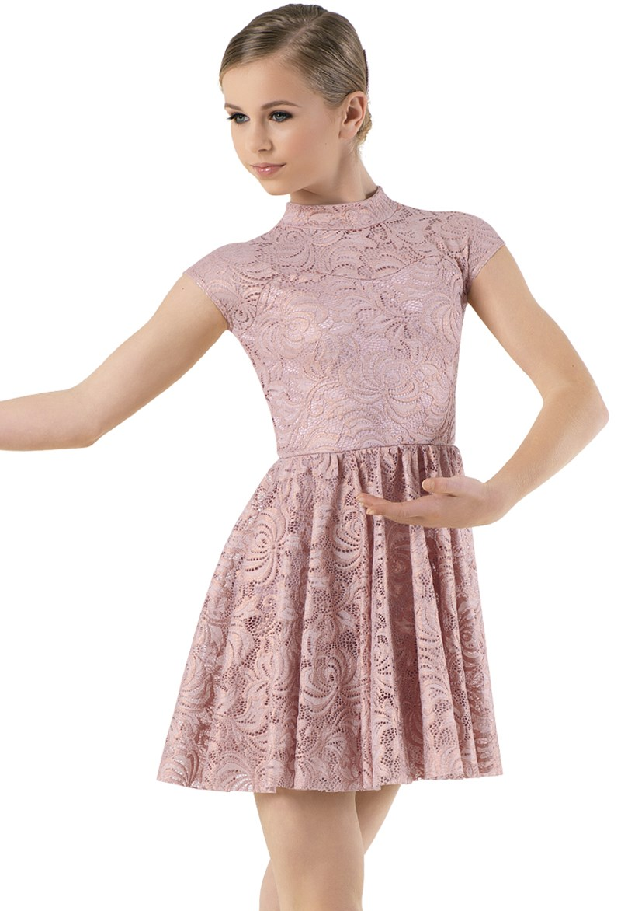 | Classic Pink | Pink Ballet | Hair High Bun  Hair pieces horizontal parallel under bun
Tap A/B  Locomotion | 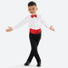 | none | Black taps | Hair High Pony  Black leo (spaghetti strap or tank-Provide own)  Black Leggings (provide own)
Pointe 1 & 2  Since You’ve Been Around | 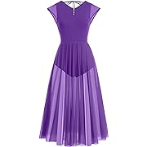  White & Purple | Classic Pink | Pink Pointe Shoes | Hair Low Pony Middle Part
Sparklers/  Shake Your Groove Thing | 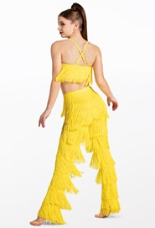 | Comp Tights | Black Taps | Hair High Pony Slicked back
Sparklers/Jump | 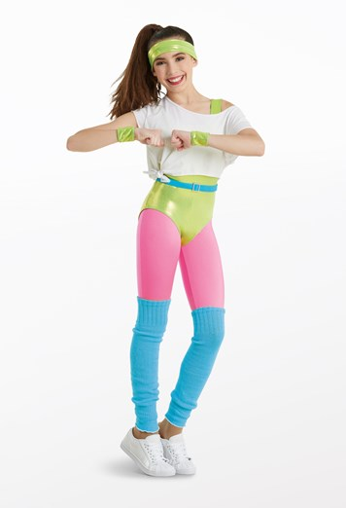 | Comp Tights | Black Taps | Hair High Pony
Beg/Int Combo  Touch the Sky  Jump In Line | 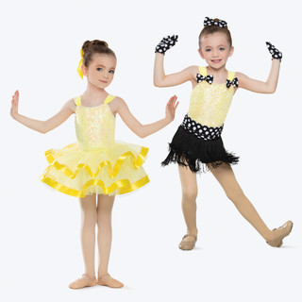 | Classic pink tights | Pink Ballet  Black Taps | Hair Bun  Gloves for tap  Black bows for tap  Black sash and fringe skirt for tap  Yellow tutu for ballet
Tues CM 2  Here Comes the Sun | 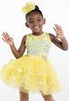 | Classic pink tights | Pink ballet | Hair bun  Yellow bow
Int/Adv Combo  B-Spark-Monster High  T-That Power  J-Electric Youth  Coral Color | 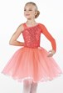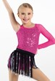 | Classic pink tights | Pink ballet shoes  Black tap shoes  Black jazz shoes | Tutu for ballet  Fringe skirt for tap  Black leggings for Jazz (provide own)
Thurs CM 1  Better When I’m Dancin | 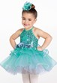 | Classic pink tights | Pink ballet shoes | Hair bun  Blue Bow
Lyrical- I Will Follow You into the Dark |  | Classic pink tights | No shoes | Black leotard for under shirt (provide own)
Modern-Anti-hero |  | Classic pink tights | No shoes
Tap C-Beat It | 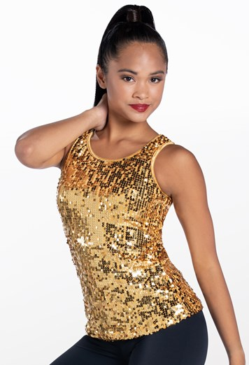  Different colors | Black taps | Black leggings  (provide your own) | Hair low middle part
Ballet C-Running up that Hill |  | Pink ballet shoes | Classic pink tights | Hair low bun middle part
Hip Hop-U Can’t Touch This | 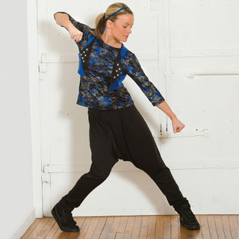 | Black or white tennis shoes |  | Mid pony middle part
Jazz- Dance the Night |  | Black leggings  (provide own) | Black jazz shoes | Middle part middle pony
Tumbling-Walking on Sunshine | 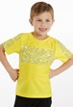 | No shoes | Black biker short  (provide own)  Black leotard  (provide own) | Low pony middle part
Musical Theater–Grease |  | Black heels | Hi-Waisted Black leggings  (provide Own) | High Pony with middle part

