Wild & Free
Class/Teacher | Song | Costume | Shoes | Tights | Hair/Accessories
Sparkler Bigs-Casey | Turn It Loose | 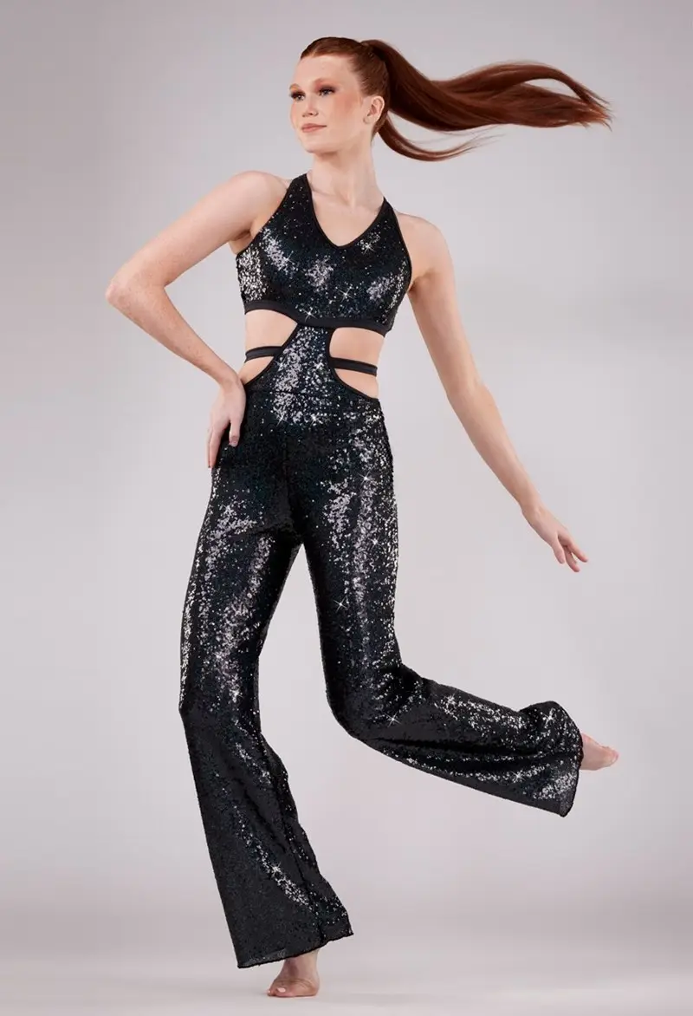 | Black jazz | Classic Pink | 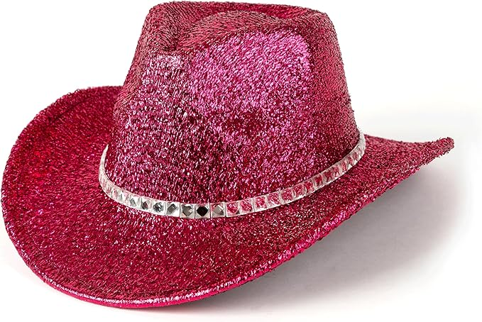  Low Pony
Sparkler Mids-Casey | Wild Blue | 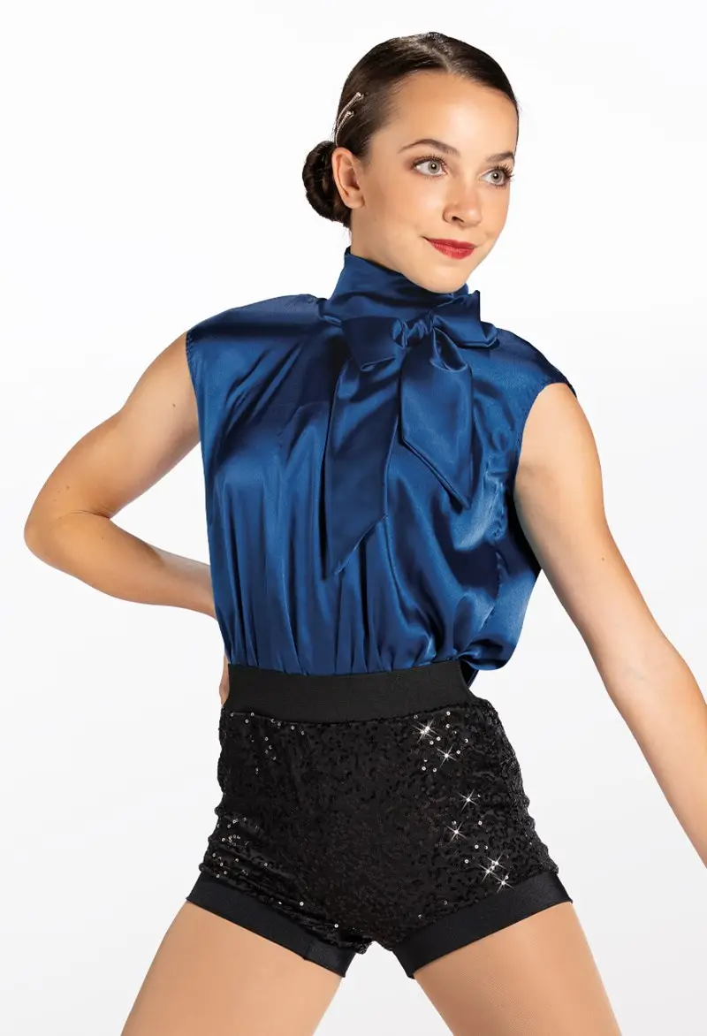 | Black Jazz | Classic Pink | Low Pony Middle Part
Sparkler Minis-Taylor | Wildflowers | 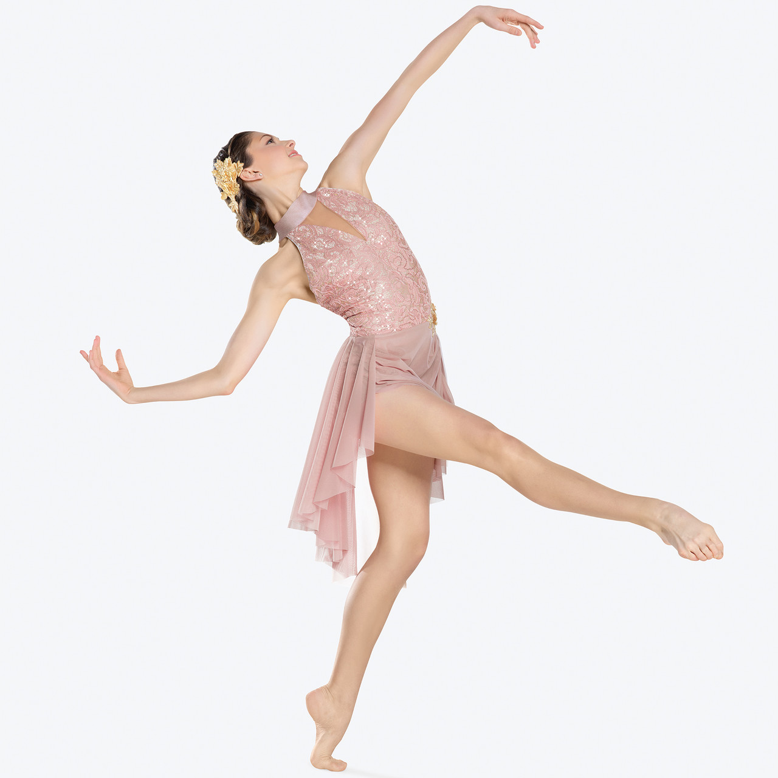 | none | Classic pink | Low pony middle part
Tap A/B-Casey | Born Free | 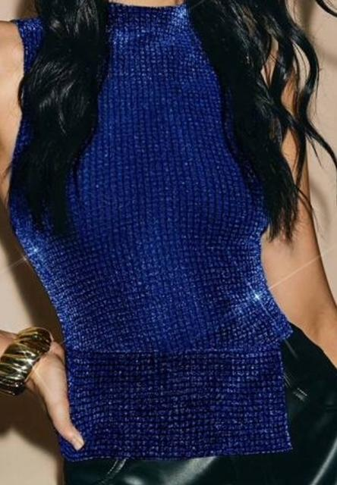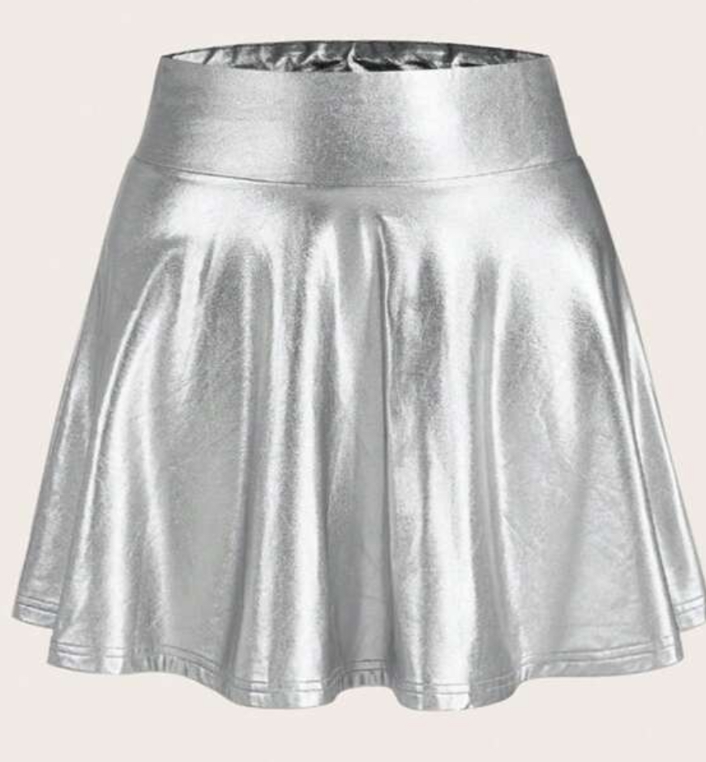 | Black tap | Classic Pink | Black booty shorts under skirt  Low Pony Middle Part
Ballet A/B-Casey | Wild Horses | 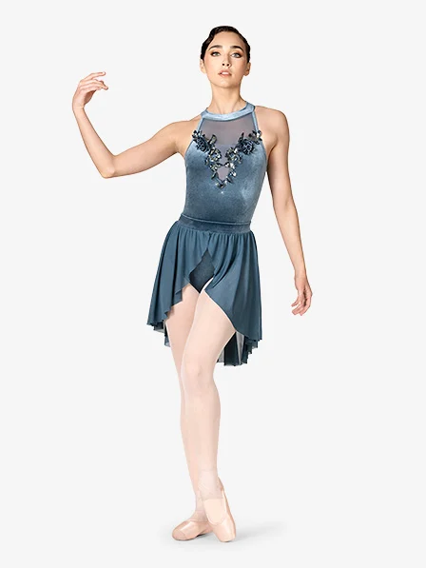 | Pink Ballet | Classic Pink | Low Pony Middle Part
Pointe-Casey | Free Fallin’ | 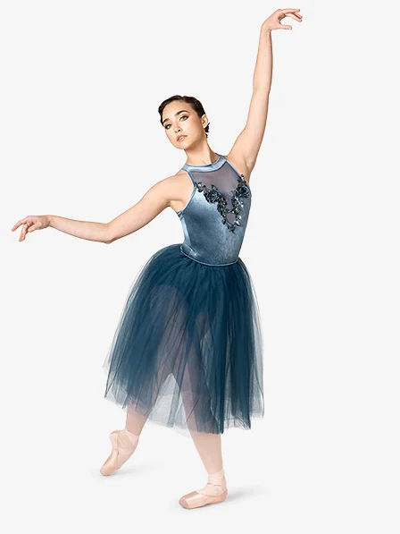 | Pink Pointe | Classic Pink | Low pony Middle Part
Jazz A/B-Casey | Free Your Mind | 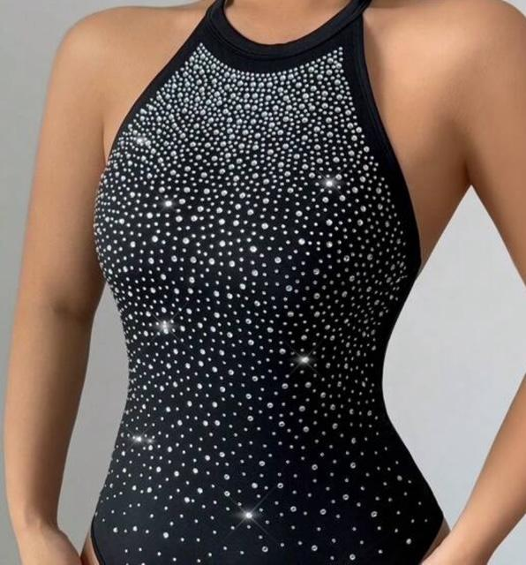 | Black Jazz | None | Black High waisted Leggings  (skinny)  Low Pony Middle Part
Adv/Combo-Robin | B-Free  T-No Strings Attached  J-Set It all Free | 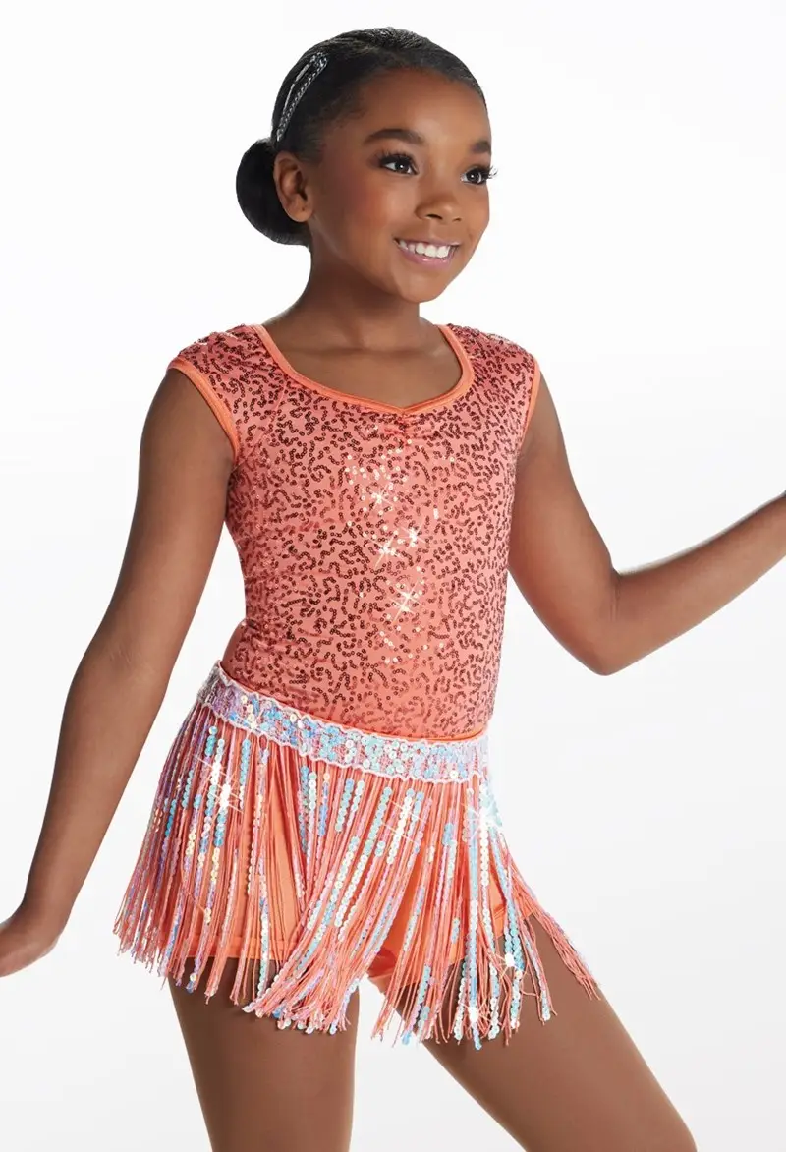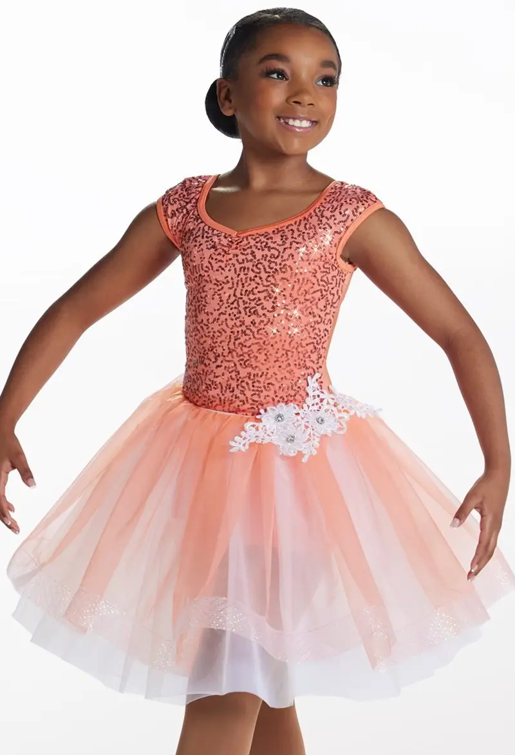 | Pink Ballet  Black Taps  Black Jazz | Classic Pink | Hair Bun
Beg/Combo-Robin | B-Try Everything  T-Wild & Free | 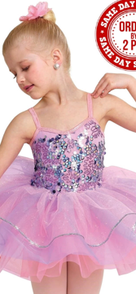 | Pink Ballet  Black Tap | Classic Pink | Tap Ribbons  Hair Bun
Int/Combo-Robin | B-Unwritten  T-Life is Better Loud | 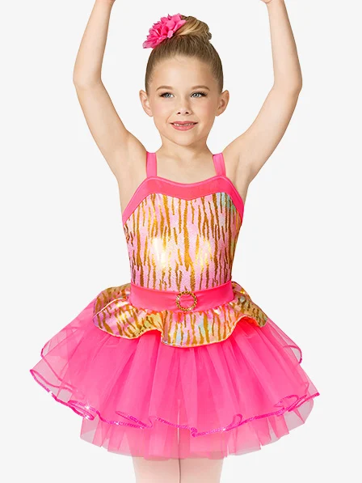 | Pink Ballet  Black Tap | Classic Pink | Black Leggings for Tap  Hair Bun
Tap C/D-Kate | Wild Things | 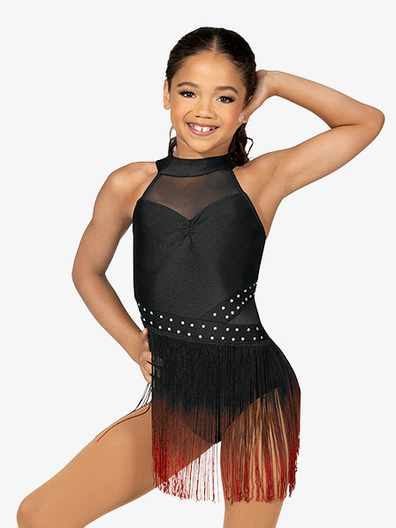 | Black Taps | Classic Pink | Low Pony Middle Part
Ballet C/D-Kate | Wild & Free | 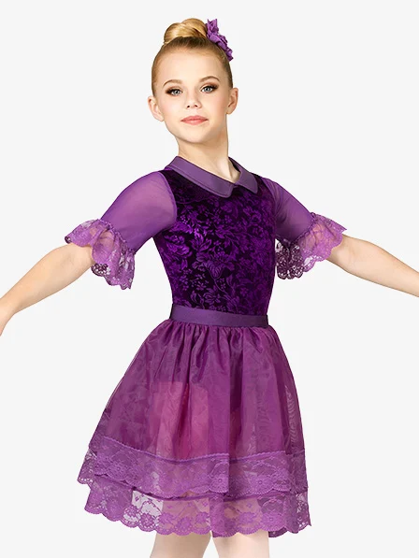 | Pink Ballet | Classic Pink | Low Pony Middle Part
Beg/Hip Hop-Kate | Wild Side | 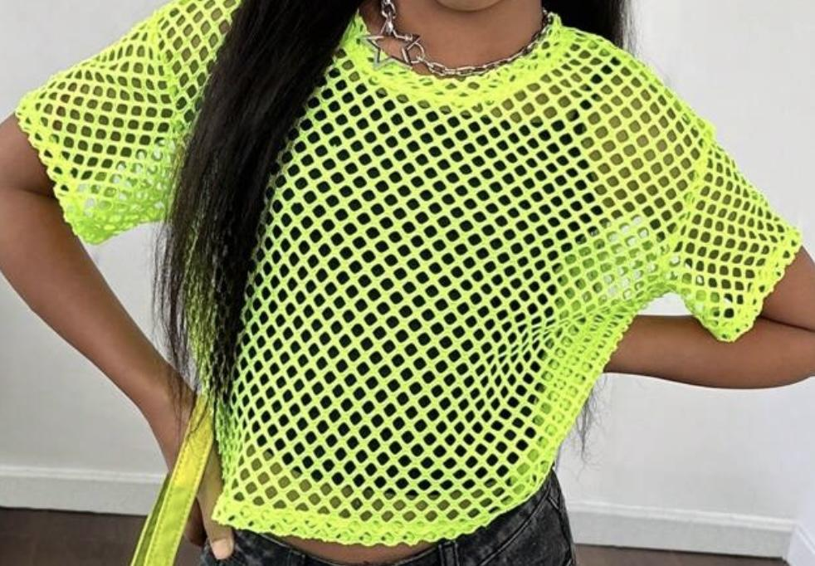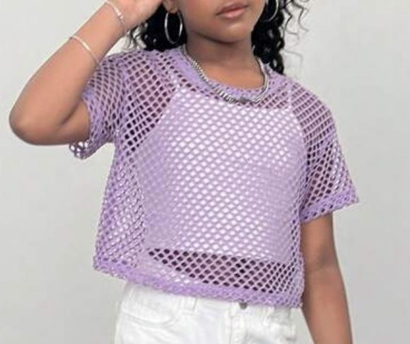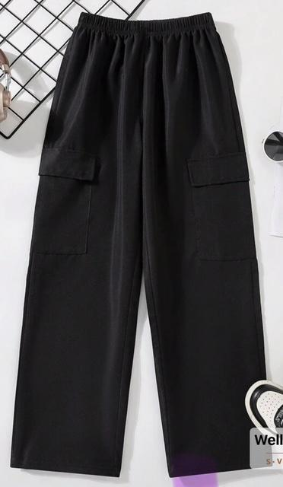 | Bare feet | None | Low Pony Middle Part
Jazz C/D-Kate | You Belong | 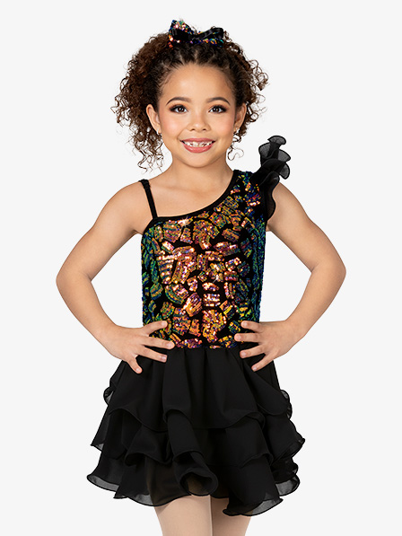 | Black Jazz | Classic Pink | Low Pony middle Part
Modern-Taylor | Free Bird | 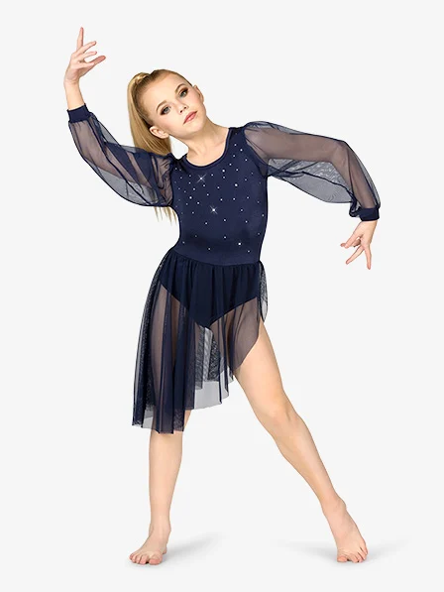 | None | Classic Pink | Low pony Middle Part
Hip Hop-Taylor | Wild Wild West | 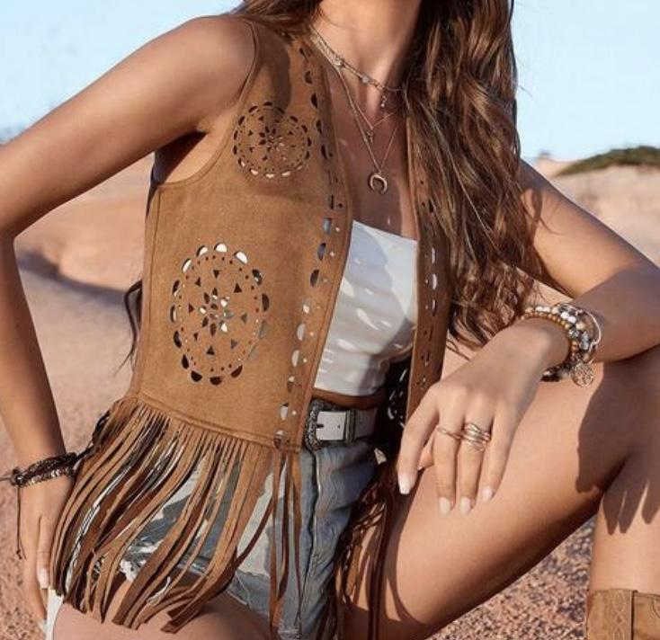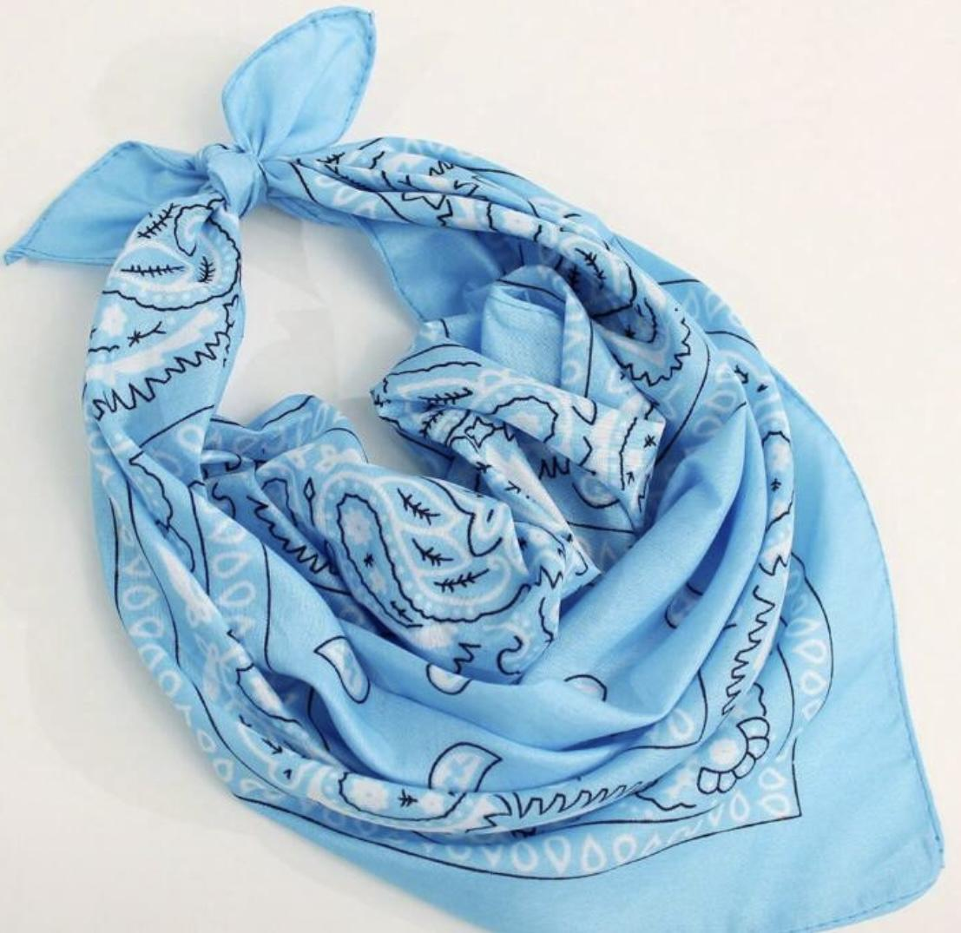 | None | Classic Pink | High Wasted Jean Shorts-  Butts covered  White Tank  Bandana  Low Pony Middle Part
Lyrical-Taylor | Free | 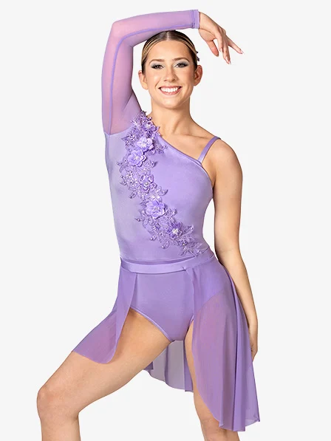 | none | Classic Pink | Low pony Middle Part
Musical Theater-Taylor | Breaking Free | 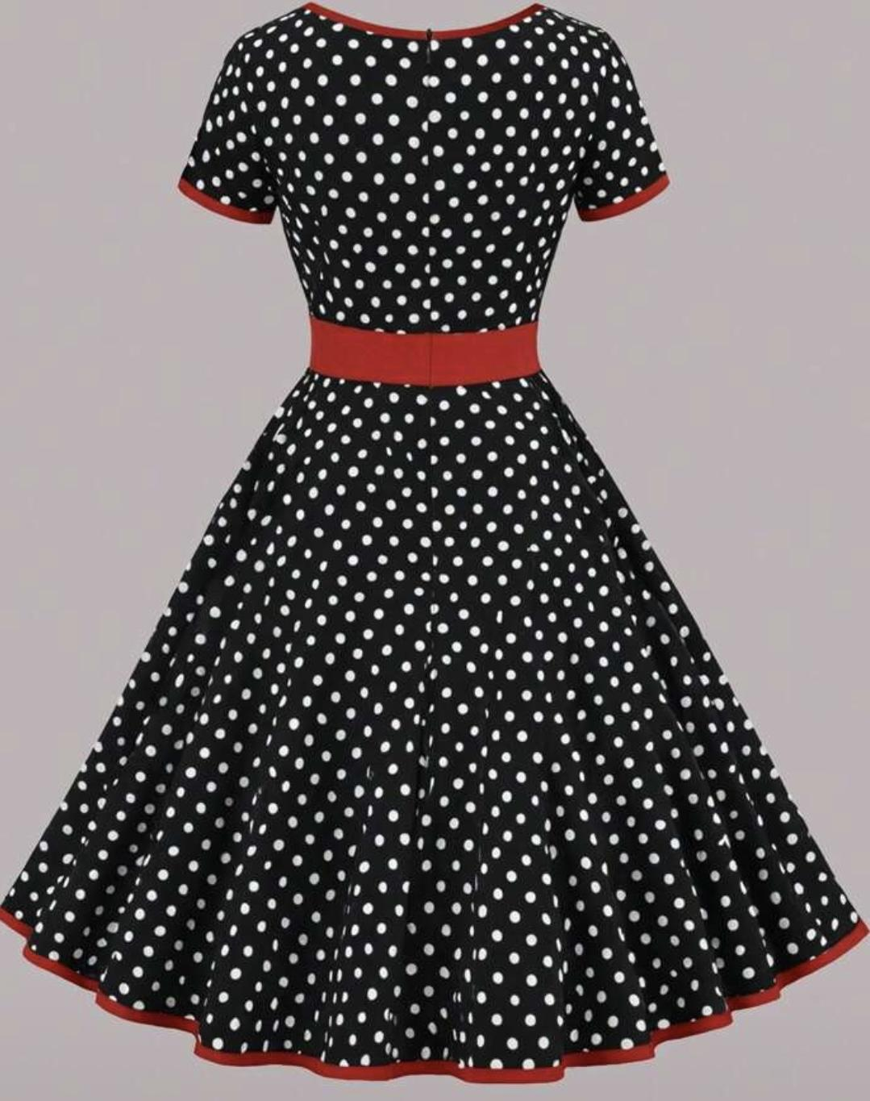 | Black/White Tennis shoes | Classic Pink | Black shorts underneath  Low Pony Middle Part

